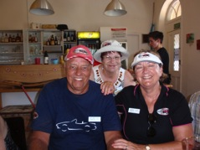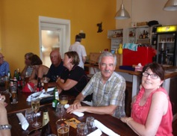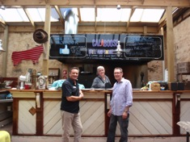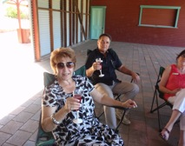

Roger & Lynn Trethewey and Barry & Lianna Parker were asked to lead the run and they did an excellent job as did Lynn with her timely instructions over the radio. Thank you all. We only managed to get one car take a wrong turn and that was a ring-in, a Porsche Boxter. I will have to have a talk with my sister and brother in law about following instructions!

As the Calaboose does not open during the week, Bruce Gordon, owner and Chef, opened the Restaurant for us as a private function. We just managed to squeeze 27 people into the lounge area, which had been set up with tables and chairs and had air conditioning and fans, but both struggled to keep the room cool due to the heat and humidity. Regardless of this, we all had a great meal of New Orleans style food and I am sure no one left there hungry or thirsty. Thank you to Bruce and our Waiter who did a wonderful job in keeping us all fed and hydrated.

It was noted during the speeches that there were 6 President’s at this gathering. WA President, Barry Parker, current President of our Club, Des Long, past President’s of our Club, Ed McCaul, Lynn Trethewey, Roger Threthewey and Alan Weber. Maybe the run should have been called “The Presidents’ Run”.

Barry & Lianna Parker thanked our Club for making them feel so welcome and presented me with a WA MX5 hat. Barrie also mentioned that if any of our Club Members go over to WA to let him know and that there could be a spare MX5 available for use.

*Poppy Hawkins*

*Events Secretary*

*8 Jan 15*

*Beryl & Walter Bullock*

27 very brave souls ventured out in the hot 38 degree temperature yesterday for the first run of the year. Most of us gathered at Clarendon Oval for morning tea and a chat and an introduction to Western Australian MX5 President, Barry Parker and his wife Lianna. It was extremely delightful to see new members, Beryl and Walter Bullock, starting off with a glass of bubbly. How very civilized and Beryl and Walter, you may just start a new trend.

We then set off for a delightful run through some of our great Fleurier Peninsular roads taking in Wickhams Hill Road, Range Road, Pages Flat Road and past the Myponga Reservoir into Carrackalinga, stopping at Normanville for lunch at the Calaboose Restaurant.

***W.A. PRESIDENT’S RUN***

***Wednesday 7th January 2015***